***Ecosystem***

Ecosystem is a community of living organisms along with their natural habitat and the non-living components of their environments this network of living and non-living components in a given area is called an **Ecosystem.** Ecosystemincludes two major components which are **Biotic and Abiotic Components.** A biome is **a large area characterized by its vegetation, soil, climate, and wildlife**.

***Soil***

Soil is formed by rocks over the course of 100 years***.*** Rocks are broken down by wind, water, heat and many other factors until they formed into soils. The different types of soils are clayey soil, sandy soil and loamy soil. Clayey soil hast lots of clay particles. Clayey soil lumps together with moisture. Clayey soil holds too much water. Sandy soils contains lots of sand particles. Sandy soil is not suitable for plants. From Sandy soil the water flows out easily between the particles. Loamy Soil is balanced mixture of clay, sand and humas. Loamy Soil is rich in minerals and microbes and allows plants to grow. Loamy Soil is also known as loam soil or garden soil.

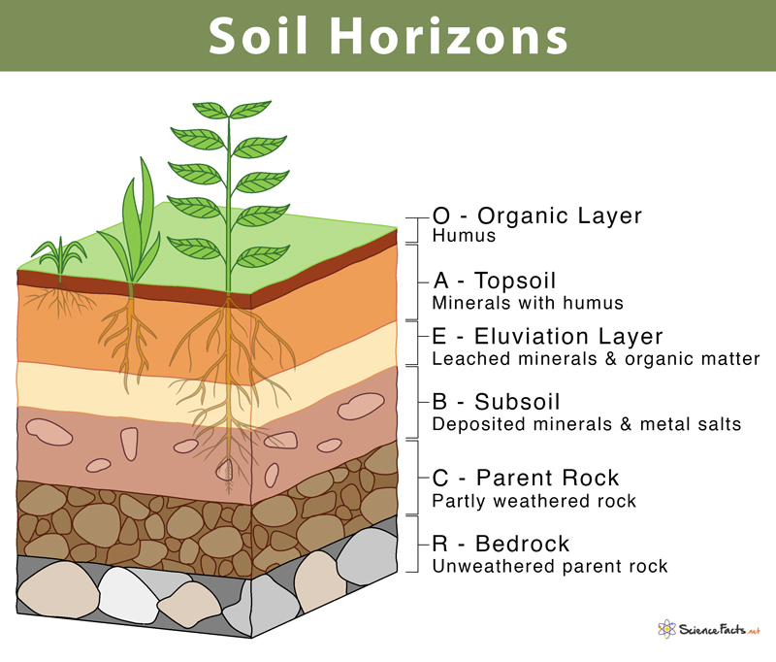

Whenever there is a strong wind a lot of the top soil washed away this is called **soil erosion.**

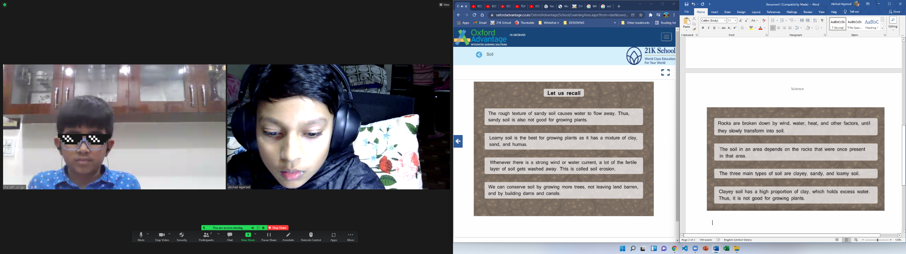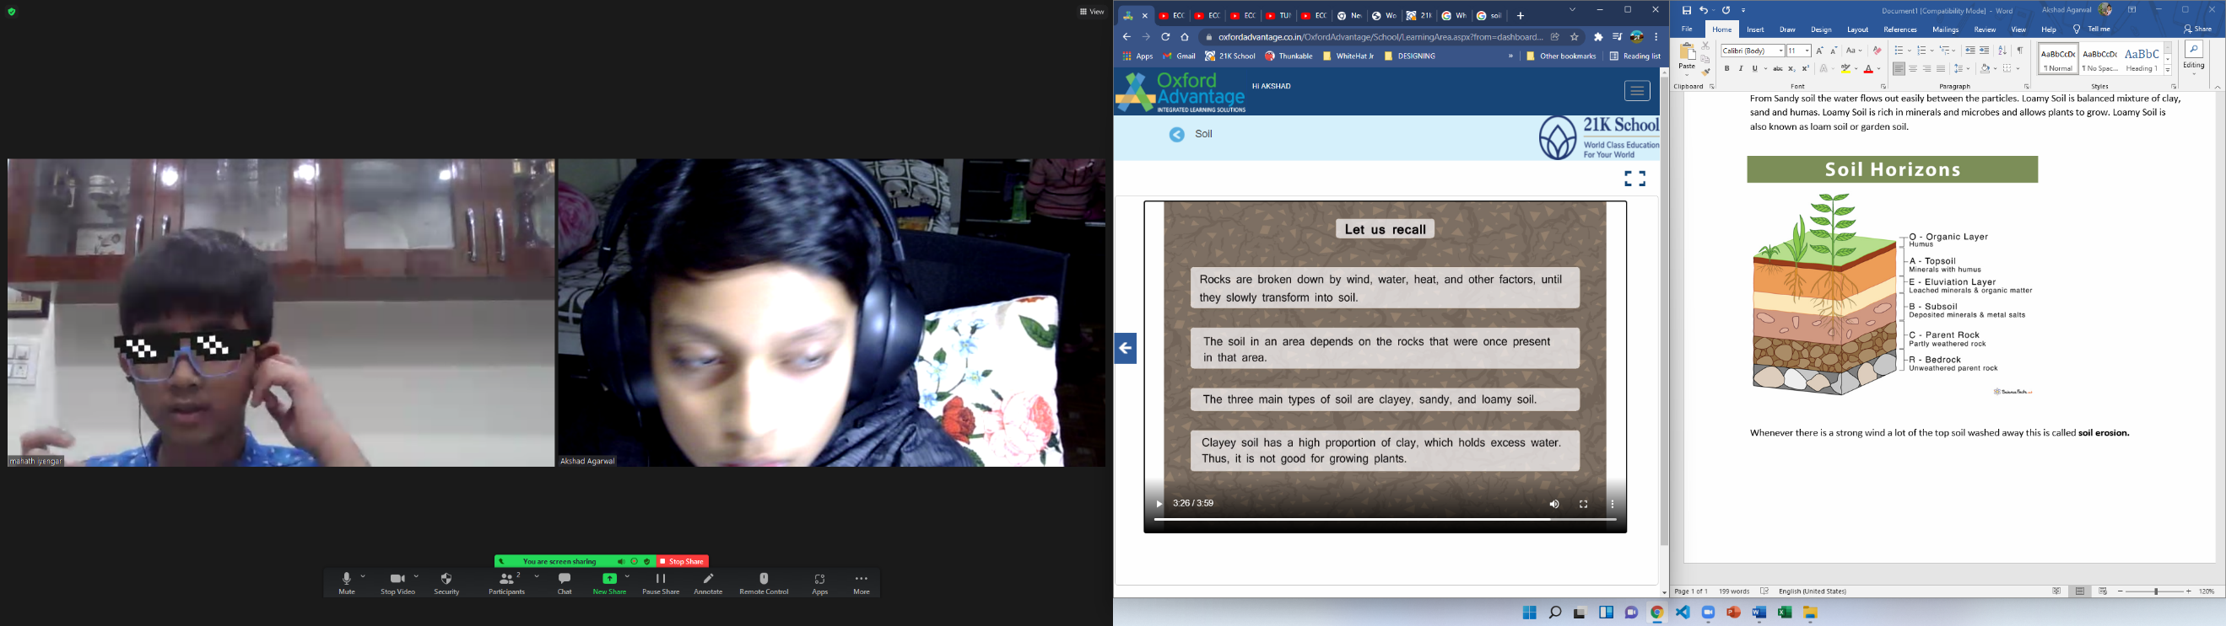

**CONSERVE SOIL! PROTECT THE SOIL!**

**Pollution**

Pollution is **the introduction of harmful materials into the environment**. Landfills collect garbage and other land pollution in a central location. They can also be created by human activity, such as trash or runoff produced by factories. Pollutants damage the quality of air, water, and land. There are different types of pollution: Air Pollution, Water Pollution, Land Pollution, Noise Pollution and Light Pollution.

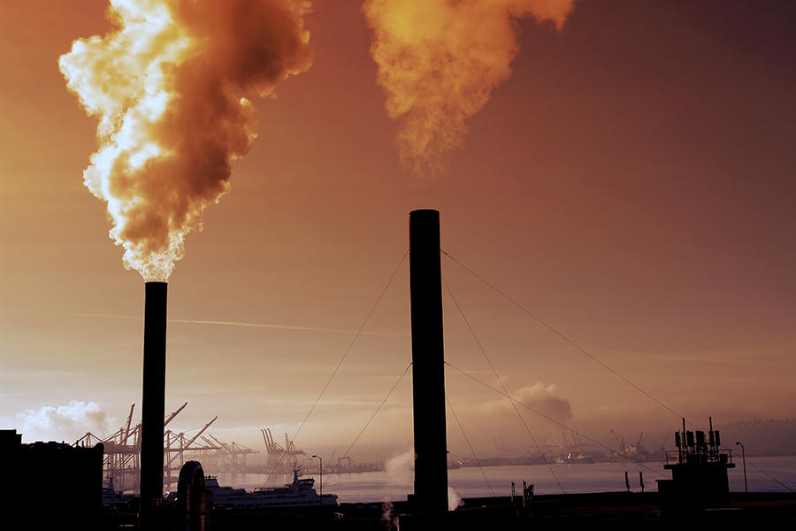

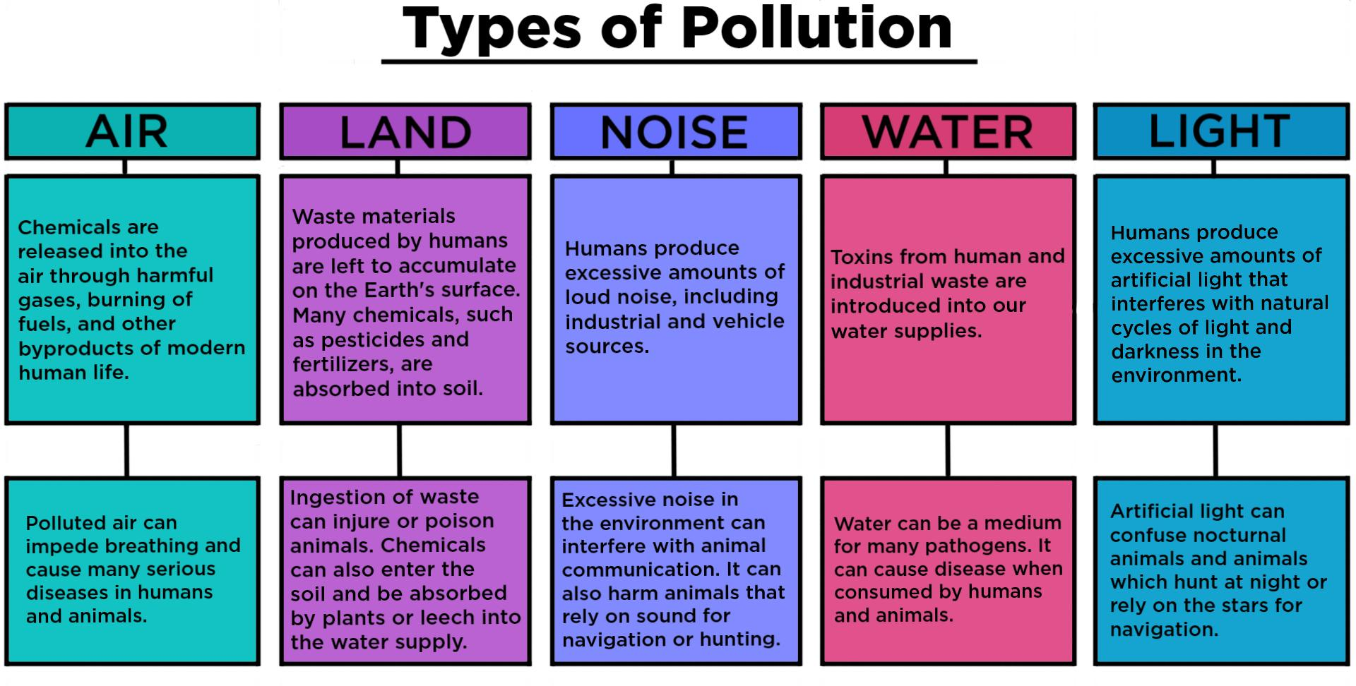

**How to stop pollution?**

**1.** Turn off lights when not in use.

**2.** Do not use Plastic bags

**3.** Recycle, Reuse and Reduce

**4.** Use Fans instead of A/C

**5.** Use CNG petrol

**6.** Do not bath animals in lakes

**7.** Reduction of forest fires and smoking

**8.** Avoid usage of crackers

**9.** Use public transport

**10.** Implant Afforestation

**STOP POLLUTION!**

**YouTube Videos**

**Forest: -**

[**https://youtu.be/LyzOq40rpwQ**](https://youtu.be/LyzOq40rpwQ)

**About Nature: -**

[**https://youtu.be/WmVLcj-XKnM**](https://youtu.be/WmVLcj-XKnM)

**Ocean: -**

[**https://youtu.be/rM6txLtoaoc**](https://youtu.be/rM6txLtoaoc)

**Air and Pollution: -**

[**https://youtu.be/E8d_JvMpoY4**](https://youtu.be/E8d_JvMpoY4)

**Soil: -**

[**https://youtu.be/Dor4XvjA8Wo**](https://youtu.be/Dor4XvjA8Wo)

**Ice: -**

[**https://youtu.be/qBBOue_AdcU**](https://youtu.be/qBBOue_AdcU)

**Water: -**

[**https://youtu.be/fwV9OYeGN88**](https://youtu.be/fwV9OYeGN88)

**Nature (Home): -**

[**https://youtu.be/mkjwxmcdb0E**](https://youtu.be/mkjwxmcdb0E)

**Mountain: -**

[**https://youtu.be/NJHcdKf5iHs**](https://youtu.be/NJHcdKf5iHs)

**Flower: -**

[**https://youtu.be/0_OxI2JZex4**](https://youtu.be/0_OxI2JZex4)

**Redwood: -**

[**https://youtu.be/3e66bnuxV2A**](https://youtu.be/3e66bnuxV2A)

**Wave: -**

[**https://youtu.be/GpNeGuP-_Gc**](https://youtu.be/GpNeGuP-_Gc)

**Earth: -**

[**https://youtu.be/MuqsIYfCmdc**](https://youtu.be/MuqsIYfCmdc)

**Ecosystem: -**

[**https://youtu.be/sKJoXdrOT70**](https://youtu.be/sKJoXdrOT70)

**Biomes: -**

[**https://youtu.be/_vAOarzqZhg**](https://youtu.be/_vAOarzqZhg)

**Biodiversity: -**

[**https://youtu.be/b6Ua_zWDH6U**](https://youtu.be/b6Ua_zWDH6U)

**Our Planets (Frozen City (Netflix)): -**

[**https://youtu.be/cTQ3Ko9ZKg8**](https://youtu.be/cTQ3Ko9ZKg8)

**Our Planet (Coastal Seas (Netflix)): -**

[**https://youtu.be/r9PeYPHdpNo**](https://youtu.be/r9PeYPHdpNo)

Thank you all for the support & kindness!

**Presented By: Satvik Mohapatra, Mahath Iyengar, Akshad Agarwal, Vivaan prabhu**